Dyna notes to remembers (steel foundation)
- Dyna pile damping results are always in viscous damping
Steady State Analysis
- SAP steady state analysis always in hysteric damping.
- Change dyna viscous damping to hysteric damping while using dyna pile impedance
- We need to scale factor or change the forces to frequency dependent (please use Manila/Houston go by file for steady state forces).
- Do not use same forces used for dyna.
- Go by 4 also can be used but confusing. Results also added are not for same time.
- only used 6 pile impedance (3 stiffness and 3 damping) as pile are not fixed on steel foundation
- When do the concrete foundation using SAP, you can use 12 pile impedance if using fixed pile philosophy.
- Frequency dependent link need to be used for steady state analysis
- Frequency‐dependent stiffness and damping (complex impedance) properties need to be included for the Link elements.
- If we have 2 or more pumps or compressor operating at different frequency (RPM) then used steady state method to calculate results
- You don’t need to put weight in Dyna 3DF file for pile impedance if using only 6 pile impedance (3 stiffness and 3 damping) as pile are not fixed on steel foundation
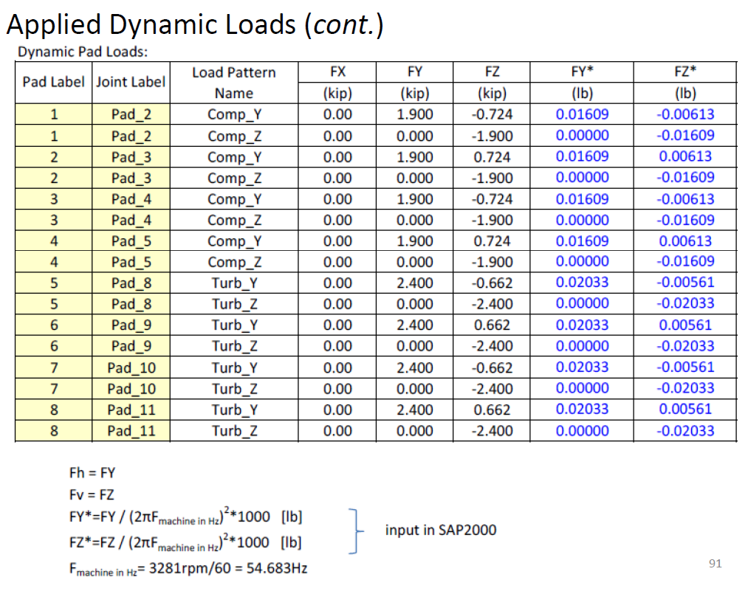
- But if piles are fixed then need to put weight in Dyna 3DF file for 12 pile impedance as cross damping and cross stiffness is dependance on weight.

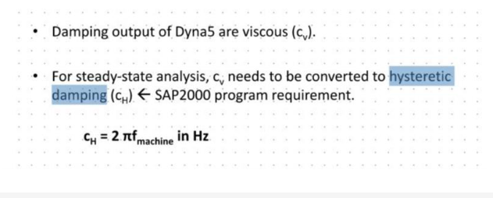
This is the frequency corresponding to damping not a machine operating frequency.
For example, if viscous damping is obtained for 30 Hz from Dyna 6.1 then hysteretic damping will be
Hysteretic damping = Viscous damping (from dyna 6.1) x 2 x π x f
Where f = 30Hz
Time History Analysis
- SAP time history analysis always in viscous damping.
- frequency independent links need to be used for time history analysis.
- Dyna stiffness and damping for the frequency need to be used. Divide the stiffness and damping by number of pile so that per pile stiffness and damping can be calculated.
- Use unbalanced forces calculated in kN for SAP. Not the same forces used for dyna.
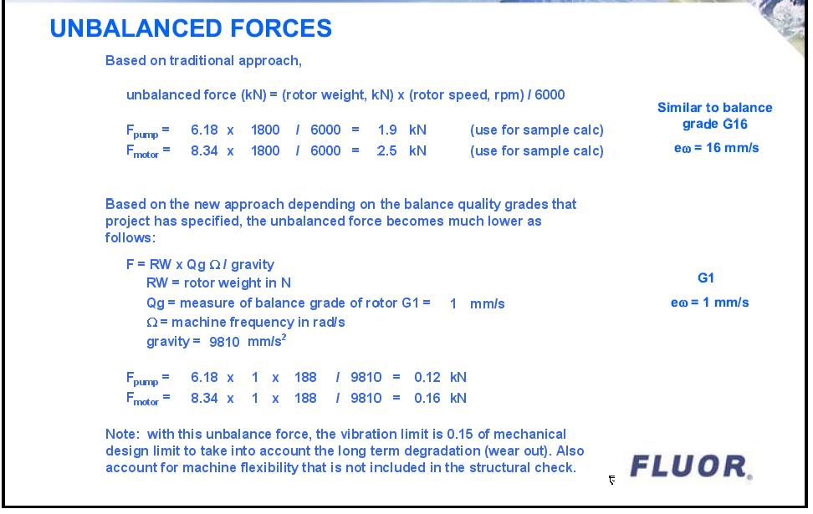
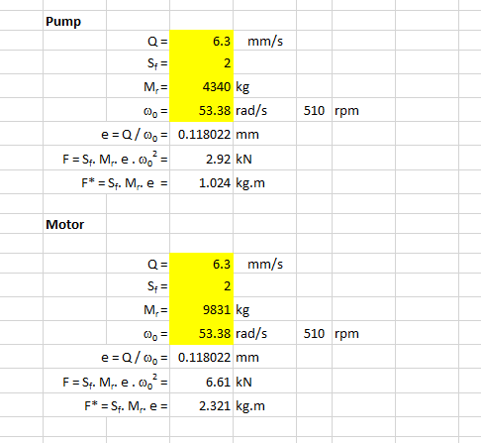
SAP force
SAP force
Dyna force
Dyna force

